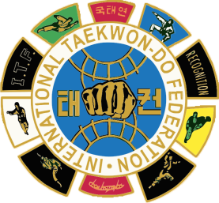ARGENTINA TAEKWON-DO FEDERATION
INTERNATIONAL INSTRUCTOR COURSE OFFICIAL ITF
To all ITF Masters and Instructors :

Celebrating the 55th anniversary of the founding of the International Taekwon-do Federation, we are honored to invite all members of the Original ITF to participate in the International Instructor Course to be held in Argentina in person and via zoom on 23 th -24th October ,2021 for other American Countries in Spanish.
Participants will obtain the ATF certificate. and as optional the ITF. They will also be able to process the International Instructor certificate.
Participation: from the category of 1 to 7 Dan.
For more information and payment :
Palmisanoeduardo@hotmail.com

Registration deadline: 15th October ,2021
Name : ………………………………
Degree:……………………………
Country:……………………………
e.mail:…………………………………
Whats app:…………………………

