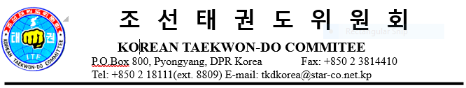

SCHEDULE
The 100th Birthday Commemoration of Gen. Choi Hong Hi

Nov. 8 Thu 17:00 Arrival Pyongyang Int. Airport
20:00 ITF EB Meeting Pyongyang Koryo Hotel
Nov. 9 Fri 09:00 Visit to Tomb of Gen. Choi Hong Hi
10:30 Watching the tele transcription Sci-tech Complex
10:40 ITF Order & Medal Awards Sci-tech Complex
15:00 Taekwon-Do Demonstration Taekwon-Do Palace
Nov.10 Sat 09:00 Visit to Taekwon-Do Holy Center
10:30 Sightseeing
15:00 Friendship Gathering Taekwon-Do Palace
19:00 Party Okryu Restaurant
Nov.11 Sun 09:00 Taekwon-Do intensive training Taekwon-Do Palace
14:30 Taekwon-Do intensive training Taekwon-Do Palace
18:00 Test for promotion Taekwon-Do Palace
Nov.12 Mon 09:00 Umpire Seminar Taekwon-Do Palace
15:00 Sightseeing
17:00 Enjoying the Art performance Art Theater
Nov.13 Tue 08:55 Departure Pyongyang Int. Airport

INFORMATION

―Taekwon-Do intensive training and Umpire Seminar will be conducted by the
Grand Masters and Masters of the Korean Taekwon-Do Committee.
You are kindly advised to wear Dobok during intensive training.
As already informed, there will be held Taekwon-Do Demonstration performed by
instructors and athletes from several countries of the world. Your active joining
are welcome.
―For the friendship gathering, we arrange some game-plays for pleasure on Nov.10.
―You’ll accommodate in Pyongyang Koryo Hotel during your stay.
Please denote in below form.
Application Form
№ | Name | Intensive training | Umpire Seminar | Demonstration | Game | Accommodations
1 | Kim Kang Chol | / |  | / |  | Double+Pak Chol
2

―During your stay in Pyongyang some visits are scheduled including the Kumsusan
Palace of the Sun, Tower of Juche Idea, Museum of Natural History and so on. Please let us know your intention or choice.
―It is a little cold in Pyongyang as November 8-13 is the beginning of winter. You
are recommended to wear overcoat or cotton-padded clothing.
Thank you.

