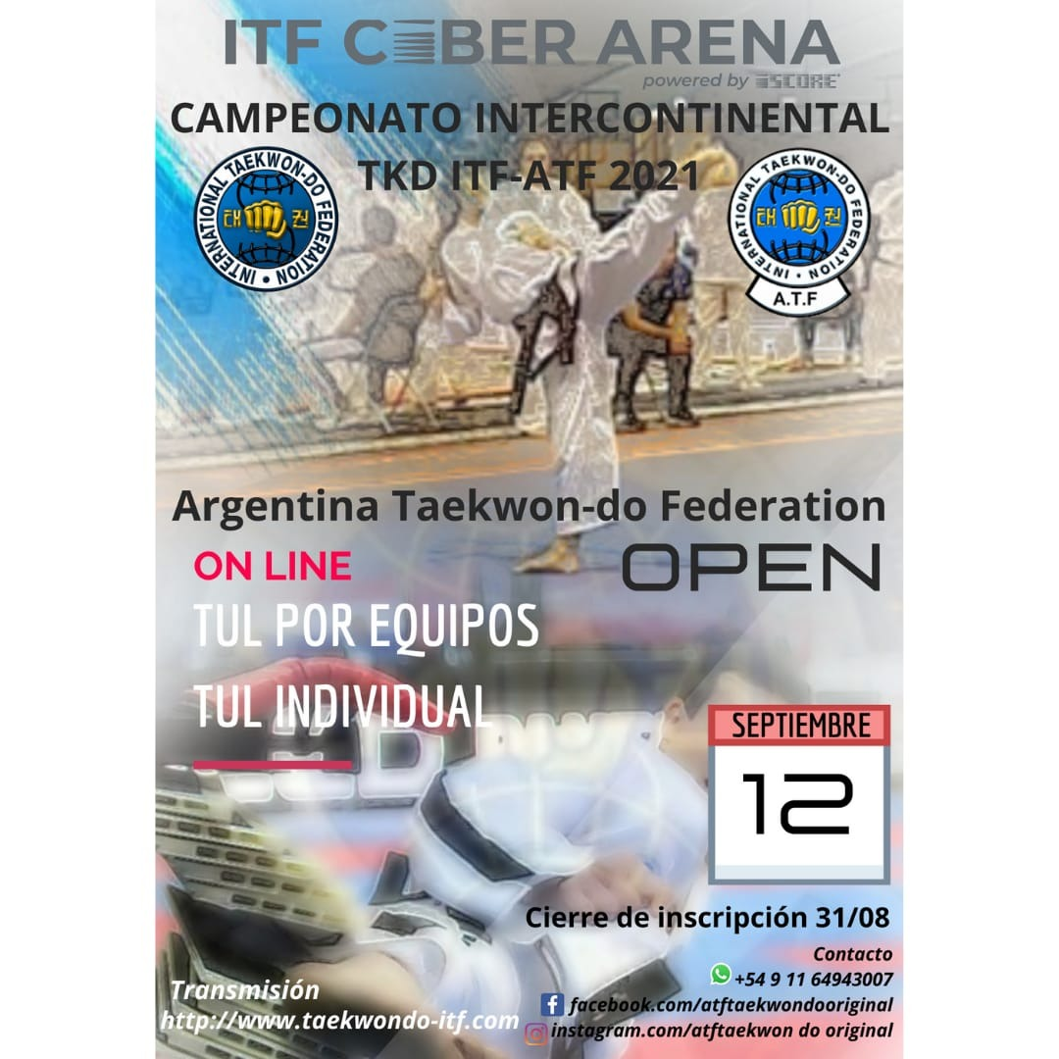

**INTERCONTINENTAL TKD ITF- CHAMPIONSHIP**

**ATF 2021**

The Argentina Taekwondo Federation has planned for this year 2021 the organization of an important Internacional event where those who register can participate in different new specilties.

It will be developed through the Ciber Arena Platform, an ultra last generation sistem designed by the ITF.

In the first stage the competition will include **Team and Individual Pattern**

**VENUE: ITF CIBER ARENA**

**PROMOTER: ARGENTINA TAEKWON-DO FEDERATION**

**Instructor's guide for the registration of competitors. ( see attached)**

**TOURNAMENT SCHEDULE:**

**REGISTRACION DEADLINE: 31th August,2021**

**ON LINE COMPETITIONS: 12th Sept. 2021**

**AWARS: EACH COMPETITOR WILL RECEIVE AN ELECTRONIC CERTIFICATE.**

**REGISTRACION:** [**ATF.TAEKWONDO-ITF.COM**](http://WWW.TAEKWONDO-ITF.COM)

**Information: whatss app:**

**+5491140745327**

**+5491164943007**

**ENTRY FEE : 10 Euros**

**ENTRY FEE FOR THE TEAM : 5 Euros   
  
For the payment fee :**

**western union**

**Destinatary : surname : Palmisano name : Eduardo Jose**

**ID : 12425799**

**address: Brasil 2316 CABA Argentina CP (1260)**

**Categories by Age_**

|  |  |
| --- | --- |
| Mini | 6 – 7 years |
| Infant | 8 a 13 years |
| Juniors | 14 a 17 years |
| Adults | 18 a 39 years |
| Veterans | 40 years and on |

**Categories by Degree:**

|  |  |  |
| --- | --- | --- |
| A | 10° a 9° Gub |  |
| B | 8° a 5° Gub |  |
| C | 4° a 1° Gub |  |
| D | Infant Black Belts | 1° Dan |
| E | Junior Black Belts | 1°, 2° y 3° Dan |
| F | Adults Black Belts | 1°, 2°,3° y 4° Dan |
| G | Veterans Black Belts | 1°,2°,3°,4°,5° y 6° Dan |

**Team Competition Rules:**

The teams may have 3, 4 or 5 competitors of one or both sexes in it.

**Teams must perform single Tul designated by the organization.**

**A COMPETITOR WHO DOES NOT TAKE PART IN AN INDIVIDUAL DISCIPLINE MAY NOT TAKE PART IN THE TEAM EVENT**

|  |  |  |
| --- | --- | --- |
| **Category** | **Degree** | **Tul** |
| **A** | **10 ° a 9° Gub** | **Saju- Jirugi/Chon Ji** |
| **B** | **8° a 5° Gub** | **Dan Gun** |
| **C** | **4° a 1° Gub** | **Joong Gun** |
| **D** | **Infant Black Belts (8 to 13 years)** | **Kwang Gae** |

**The E, F y G categories they will be able to make the Tul of their choice, taking into account that all the Balck Belt Tuls are enabled , but always considering that they must do the one that corresponds to the lowest grade of the competitor that belongs to that team**

**INDIVIDUAL COMPETITION RULES**

**Competitors must perform single Tul designated by the organization.**

|  |  |
| --- | --- |
| **Category** | **Tul** |
| **A** | **Saju- Jirugi/Chon Ji** |
| **B** | **Dan Gun** |
| **C** | **Joong Gun** |
| **D** | **Kwang Gae** |

**Categories E, F y G will perform a Tul of their choice that corresponds to their degree.**

PROTOCOL ( PROCEDURE)

Forms should be done in gyms or in places that allow easy movements. They may not take place in parks, parking lots or inappropiate places. All competitors must present the official ITF dobok.   
They will not be able to make the Tul with any type of footwear



**Video Production Requirements**

1. The camera should be positioned and fixed straight in front of the athlete in the starting position.

2. The camera should be placed at a height of 110-130 cm from the ground and sideways (16:9) if a mobile phone is used (approximately at the height of the eyes of a referee who is sitting in a chair).

3. The distance of the camera from the athlete should allow the athlete to remain within the frame during the pattern execution.

4. No zoom is allowed on the athlete's movements.

5. Stable plan when performing each technique.

6. If during the execution of a technique the athlete goes out of the frame, the camera can be rotated and follow the athlete, but it cannot zoom in or move from the original point.

7. The athlete should try to choose a space which allows to perform the technique without interruption and obstacles.

8. The athlete must wear an ITF-Approved, official Dobok

9. The athlete must be barefoot.

10. The video should have sound (the athlete's exhalations must be clear).

11. The video must be uniform and may not be a compilation of any kind. Otherwise, the athlete will be disqualified.

12. Any interference or enhancements of the video are prohibited.

**Individual Pattern Presentation**

The match begins with a designated pattern.

1. Video starts at Cha-ryeot;
2. The athlete greets Taekwon;
3. Athlete takes the Joon-bi position for the pattern to be performed
4. Pattern execution starts
5. Athlete Pattern execution starts at the Joon-bi position for the pattern to be performed
6. End of the video.

**Team Tul Presentation**

1. Video starts at Cha-ryeot said by the captain. All the team is formed in line outside the competition área in front of the camera
2. They immediately advance until they are in the formation chosen for the realization of the Tul.

From the Cha-ryeot till the beginning of the Tul it should **not exceed 15 seconds.**

1. After the pattern is completed and after shouting the name of the pattern, the athlete returns to the Joon-bi position and waits 2-3 seconds in the Joon-bi position.
2. Once the Tul is finish the captain must give the order to stop and rest,
3. Final greeting, end of the video