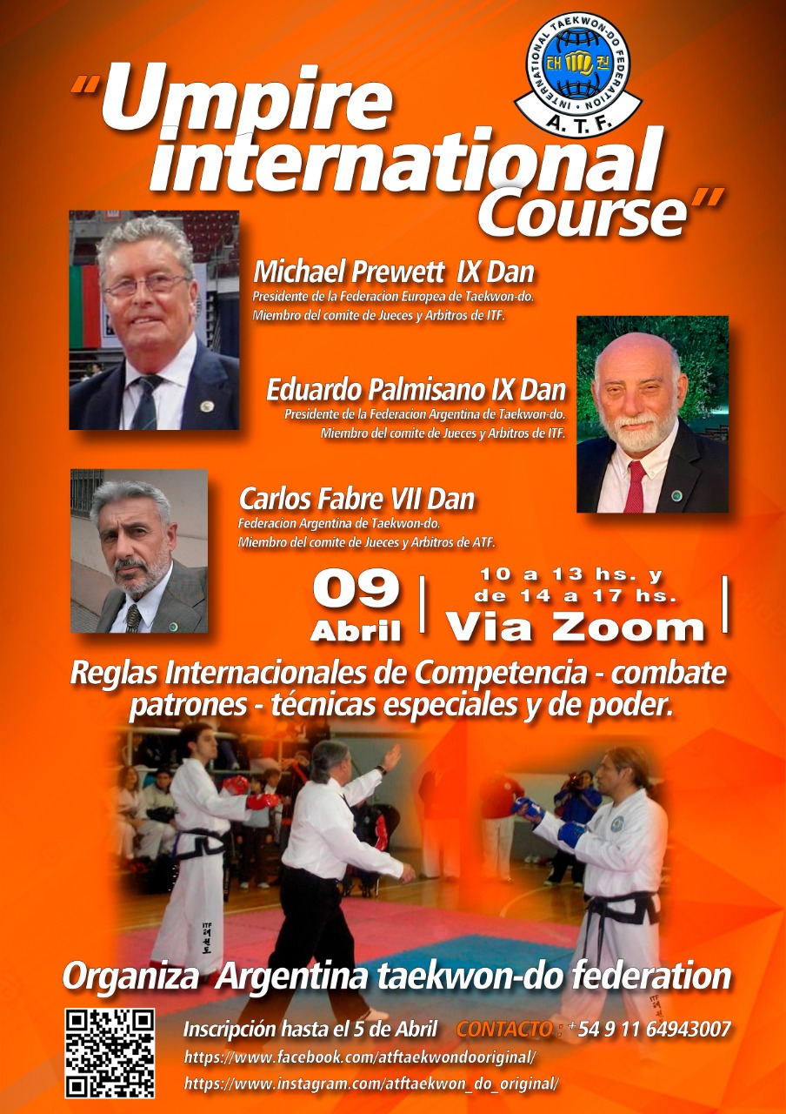

**UMPIRE INTERNATIONAL COURSE**

**OFFICIAL INFORMATION**

The Argentina Taekwon-do Federation invites all ITF members to participate in the International Umpire Course to be held on the day

**April 9, 2022 - from 10:00 a.m. to 1:00 p.m. and from 2:00 p.m. to 5:00 p.m. (Argentina time).**

The Course is Official ITF therefore all participants have the option of requesting the Class A and/or B Umpire Certificate depending on their grade.

The seminar consists of 2 stages, the first part will be carried out in person and/or virtual, via zoom and on YouTube, depending on the place of residence of the participants. It will start at 10:00 a.m. (Argentina time) until 1:00 p.m.

The first part of the course will be in charge of GM Eduardo Palmisano, member of the ITF Judges and Referees Committee and Master Carlos Fabre VII Dan, member of the ATF Referees Committee. The second part will be dictated Virtually via zoom, by G. Master Michael Prewett. Member of the ITF Judges and Referees Committee and President of the European Taekwon-do Federation.

This last stage will begin at 2:00 p.m. (Argentina time) ending at 5:00 p.m. The first stage will be developed in the Spanish language, and the second in English with translation into Spanish.

The organization will provide the link for each participant to enter directly. Each Participant will have to enter the link with the camera on and with the audio off and with their last name at the bottom of their profile. In addition, the organization will provide a registration number that will be placed by the participant in his visible profile before his name. Example. 1-Juan Lopez.

This requirement is essential. It is recommended previously for a quick entry, to enter the zoom and configure these data.

Note : All participants must present themselves in the official Judge uniform during the two stages of the course . White shirt, blue tie, blue pants and white shoes.

Participants must be 15 minutes before the start of each stage in the zoom waiting room.

**Registration deadline on April 7, 2022 at 11:59 p.m.**

Official ATF Diplomas will be delivered.

**Optional: ITF Umpire Diplomas Class A: 125 Euros, Class B: 65 Euros.**

**SEMINAR AGENDA:**

**1ST STAGE**

1- PURPOSE- AND CLASSES OF UMPIRES

2- COMPOSITION OF THE COUNCIL OF COMPETENCE AREAS

3- RIGHTS AND DUTIES OF THE PRESIDENT OF THE JURY

4- RIGHTS AND DUTIES OF THE REFEREES

5- BEHAVIOR

6- DRESS REGULATION

7- TREATMENT OF THE REFEREES

8- REGULATION OF PENALTY

9- OFFICIAL TERMS OF JUDGMENT

10- EVALUATION SIGNS

11- SCORING PRACTICE

**SECOND STAGE:**

1. UPDATE OF THE TULLE, COMBAT, POWER TECHNIQUE, SPECIAL

TECHNIQUE AND SELF-DEFENSE COMPETITION RULES.

2- ALL PARTICIPANTS WILL BE ABLE TO ASK QUESTIONS THAT WILL BE WRITTEN IN THE YOUTUBE AND ZOOM CHAT.

3- FINALIZATION: DELIVERY OF THE CERTIFICATES TO THOSE PRESENT AND VIA E-MAIL TO THE VIRTUAL PARTICIPANTS.

**ORGANIZING COMMITTEE**